A Project Report on

STOCK PRICE PREDICTION AND ANALYSIS USING DEEP LEARNING

Submitted in partial fulfillment of the requirements for the award of the Degree of
Bachelor of Technology
in
Department of Computer Science & Engineering
By
XXXXXXXXXX XXXXXXXXXXX
XXXXXXX XXXXXXXXXX
XXXXXXXX XXXXXXXXXX
XXXXXXXXXXXX XXXXXXXXXXX

Under the Esteemed Supervision of

Sri XXXXXXXXXX _{M.Tech.,}

Assistant Professor

Department of Computer Science & Engineering

Sri vasavi institute of engineering& technology
(Affiliated to JNTUK, Kakinada and Approved by AICTE, New Delhi)
NANDAMURU
<2020 – 2024>

CERTIFICATE

This is to certify that the thesis entitled ”
STOCK PRICE PREDICTION AND ANALYSIS USING DEEP LEARNING” is being submitted by

XXXXXXXXXX XXXXXXXXXXX
XXXXXXX XXXXXXXXXX
XXXXXXXX XXXXXXXXXX
XXXXXXXXXXXX XXXXXXXXXXX
in partial fulfillment of the requirements for the award of degree of B.Tech in Computer Science and Engineering from Jawaharlal Nehru Technological University Kakinada is a record of bonafide work carried out by them at “Sri vasavi institute of engineering and technology”
The results embodied in this Project report have not been submitted to any other University or Institute for the award of any degree or diploma.

PROJECT GUIDE HEAD OF THE DEPARTMENT
Sri XXXXXXXXXXX Sri XXXXXXXXXXXXo

ACKNOWLEDGEMENT

We take great pleasure to express our deep sense of gratitude to our project guide Sri XXXXXXXXXXX Associate Professor, for his valuable guidance during the course of our project work.
We would like to thank XXXXXXXXXXXX Head of the Department of Electrical and Electronics Engineering for his encouragement.
We would like to express our heart-felt thanks to Dr.XXXXXXXXXXXXXXX, Principal, Sri Vasavi Institute of Engineering & Technology, Nandamuru for providing all the facilities for our project.
Our utmost thanks to all the Faculty members and Non Teaching Staff of the Department of Computer Science and Engineering for their support throughout our project work.
Our Family Members and Friends receive our deepest gratitude and love for their support throughout our academic year.

XXXXXXXXXX XXXXXXXXXXX
XXXXXXX XXXXXXXXXX
XXXXXXXX XXXXXXXXXX
XXXXXXXXXXXX XXXXXXXXXXX

ABSTRACT

It has never been easy to invest in a set of assets, the abnormally of financial market does not allow simple models to predict future asset values with higher accuracy. Machine learning, which consist of making computers perform tasks that normally requiring human intelligence is currently the dominant trend in scientific research. In stock market the decision on when buying or selling stock is important in order to achieve profit. There are number of techniques that can be used to help investors in order to make a decision for financial gain. In this project work I have propose a prediction algorithm that will give the relation between the dependent factor like price and independent factors like opening price, closing price, high value of stock, low value of stock and volume of stocks bought. In this project, we have explained development of stock price prediction with the use of deep learning algorithm. In this work to use LSTM and RNN algorithms of deep learning architecture for the price prediction
Keywords: - Financial market, Predict, Machine Learning, Stock Market, Decision,Deep Learning Algorithm, RNN and LSTM.

LIST OF CONTENTS

CONTENTS PAGE NO
LIST OF FIGURES i
1. INTRODUCTION ( )
1.1Overview of the project ( )
1.2 Feasibility Study
1.3 Scope
2. LITERATURE SURVEY ( )
3. SYSTEM ANALYSIS ( )
3.1 About the software

4. SYSTEM DESIGN
4.1 Diagrams

5. CODING & IMPLEMENTATION ( )

6. SYSTEM TESTING ( )

7. RESULTS ( )

8. CONCLUSION ( )

REFERENCES ( )

APPENDIX-A ( )

LIST OF FIGURES

FIGURE | Page number

Chapter 1
INTRODUCTION

- INTRODUCTION

1.1 Overview of the project

Forecasting stock prices is a multifaceted endeavor shaped by a myriad of variables, encompassing market sentiment, economic indicators, and company performance. Over recent years, there has been a notable surge in the adoption of advanced deep learning methodologies, notably Recurrent Neural Networks (RNNs) and Long Short-Term Memory (LSTM) networks, renowned for their adeptness in capturing the intricate sequential dependencies inherent in time-series datasets such as stock prices. This project centers on harnessing the capabilities of RNN-LSTM architecture to predict the trajectory of stock prices for Google (Alphabet Inc.), a prominent player in the technology sector. Through the utilization of historical stock price data and pertinent features, the aim is to construct a predictive framework that empowers investors and traders with insights to navigate decisions pertaining to Google's stock.
The project unfolds through a series of pivotal stages. Initially, historical stock price data for Google is procured from reputable sources and subjected to preprocessing procedures to rectify missing values and standardize the data. Subsequently, an optimal RNN-LSTM architecture is devised, encompassing explorations into diverse network configurations to refine performance. Guided by the principles of model training, parameters are meticulously fine-tuned to bolster the model's precision and its capacity to generalize. Evaluation of the trained model entails the application of standardized metrics such as Mean Absolute Error (MAE) and Mean Squared Error (MSE), facilitating a comparative analysis between predicted and actual stock prices gleaned from a dedicated test dataset.
Ultimately, the overarching objective is to operationalize the trained model as a pragmatic tool for forecasting Google's stock prices. Through the deployment of predictive capabilities on unseen data and the elucidation of resultant forecasts via visualization techniques, the aim is to underscore the model's efficacy in discerning underlying market patterns and trends. Beyond its technical merits, this project serves as a testament to the applicative potential of deep learning methodologies in the realm of financial forecasting, furnishing invaluable insights for investors and financial analysts endeavoring to harness machine learning for data-driven decision-making in the dynamic landscape of Google's stock market.
1.2 Feasibility study

Every project is feasible provided given unlimited resources and infinite time. Unfortunately the development of a computer-based system is more likely to be plagued by resource scarcity and stringent schedules. It is both necessary and prudent to evaluate the feasibility of a project at earliest possible time. Wastage of manpower and financial resources and untold professional embarrassment can be avoided if an ill-conceived system is recognized early in the development phase. So a detailed study was carried out to check the workability of the proposed system. Feasibility study is a test of system proposal regarding its workability, impact on the organization, ability to meet user needs and effective use of resources. Thus, when an application is proposed, it is normally goes through a feasibility study before it is approved for development.
Economic Feasibility
Economic analysis is the most frequently used technique for evaluating the effectiveness of a proposed system. More commonly known as Cost / Benefit analysis, the procedure is to determine the benefits and savings that are expected from a proposed system and compare them with costs. If benefits outweigh costs, a decision is taken to design and implement the system. Otherwise, further justification or alternative in the proposed system will have to be made if it is to have a chance of being approved. This is an outgoing effort that improves in accuracy at each phase of the system life cycle.

Technical Feasibility
Technical feasibility is the most difficult area to ensure at initial stage. Since te objectives, functions, performance cannot be predicted to its fullest, everything seems possible, provided the right assumptions are made. It is essential that the process of analysis and definition can be conducted in parallel with an assessment of technical feasibility. The consideration that is normally associated with technical feasibility includes resource availability at the organization where the project is to be developed and implemented.
Operational Feasibility
Operational feasibility refers to the measure of solving problems with the help of the proposed system. It helps in taking advantage of the opportunities and fulfills the requirements as identified during the development of the project.
1.3 Scope
This project entails creating and deploying a predictive model that utilizes RNN-LSTM architecture to predict Google's (Alphabet Inc.) stock prices. The process involves gathering and preprocessing historical stock price data, crafting and training an optimized RNN-LSTM network, assessing its performance using standard metrics against actual data, and finally, making the model available as a practical tool for investors and traders to inform their decisions regarding Google's stock. Through meticulous experimentation and refinement, the project aims to demonstrate the efficacy of deep learning techniques in capturing the intricate nuances of stock market dynamics, thereby providing valuable insights for navigating the ever-evolving landscape of Google's stock market.

Chapter 2
LITERATURE SURVEY
2. LITERATURE SURVEY
The current study is anchored on a literature review paradigm. For any study, a literature
review is an integral part of the entire process (Fink, 2005; Hart, 1998; Machi and McEvoy,
2016) In general, literature reviews involve database retrievals and searches defined by a
specific topic (Rother, 2007). To perform a comprehensive literature review, researchers
adopt various approaches for organizing and synthesizing information, adopting either a
qualitative or quantitative perspective for data interpretation (Baumeister and Leary, 1997;
Cronin et al., 2008; Fink, 2005; Hart, 1998; Lipsey and Wilson, 2001; Petticrew and Roberts,
2005; Rocco and Plakhotnik, 2009; Torraco, 2005).
For the current study, the researcher adopts a narrative literature review approach.
Narrative review or more commonly refer to as traditional literature review is a
comprehensive, critical, and objective analysis of the current knowledge on a topic (Charles
Stuart University Library, 2018). The review should be objective insofar as it should have a
specific focus but should provide critiques of important issues (Dudovskiy, 2018). More
importantly, the results of a narrative review are qualitative in nature (Rother, 2007).
The study follows the suggestion of Green et al. (2006) with regard to synthesizing search
results retrieved from computer databases. For the current study, the researcher used
Google Scholar as a starting point, followed by searches within ProQuest and PsycINFO.
Keywords used for searches were “student evaluation of teaching”and related terminologies
(see next section for more information on SET synonymous terms). Selections of relevant
articles are explicit and potentially biased insofar as the researcher focuses on the search,
experience, and credence qualities of providers within SET studies. Data analysis methods
consist of a procedure for organizing information into specific themes developed by Miles
and Huberman (1994) and Glaser’s (1965, 1978) technique for continuous comparison o
2. Methodology
The current study is anchored on a literature review paradigm. For any study, a literature
review is an integral part of the entire process (Fink, 2005; Hart, 1998; Machi and McEvoy,
2016) In general, literature reviews involve database retrievals and searches defined by a
specific topic (Rother, 2007). To perform a comprehensive literature review, researchers
adopt various approaches for organizing and synthesizing information, adopting either a
qualitative or quantitative perspective for data interpretation (Baumeister and Leary, 1997;
Cronin et al., 2008; Fink, 2005; Hart, 1998; Lipsey and Wilson, 2001; Petticrew and Roberts,
2005; Rocco and Plakhotnik, 2009; Torraco, 2005).
For the current study, the researcher adopts a narrative literature review approach.
Narrative review or more commonly refer to as traditional literature review is a
comprehensive, critical, and objective analysis of the current knowledge on a topic (Charles
Stuart University Library, 2018). The review should be objective insofar as it should have a
specific focus but should provide critiques of important issues (Dudovskiy, 2018). More
importantly, the results of a narrative review are qualitative in nature (Rother, 2007).
The study follows the suggestion of Green et al. (2006) with regard to synthesizing search
results retrieved from computer databases. For the current study, the researcher used
Google Scholar as a starting point, followed by searches within ProQuest and PsycINFO.
Keywords used for searches were “student evaluation of teaching”and related terminologies
(see next section for more information on SET synonymous terms). Selections of relevant
articles are explicit and potentially biased insofar as the researcher focuses on the search,
experience, and credence qualities of providers within SET studies. Data analysis methods
consist of a procedure for organizing information into specific themes developed by Miles
and Huberman (1994) and Glaser’s (1965, 1978) technique for continuous comparison of
previously gathered data.
3. Defining student evaluation of teaching
In relation to students’college experience, determining whether a course or a teacher is good
or bad can be equated to measuring service quality (Curran and Rosen, 2006). This is
especially the case with regard to SETs. The concepts behind SETs have been discussed
since the early 1920s (Otani et al., 2012), and literally thousands of studies have been carried
out on these various interrelated concepts (Marsh, 2007). Furthermore, within the vast
spectrum of literature on the topic, a variety of related terms are used interchangeably.
Hence, a thorough, comprehensive literature review is impossible.
SET is a relatively recent term that is used synonymously with several previous
terminologies such as Student Evaluation Of Educational Quality (SEEQ) (Coffey and
Gibbs, 2001; Grammatikopoulos et al., 2015; Lidice and Saglam, 2013), SET effectiveness
(Marsh, 1987, 2007), student evaluation of teacher performance (Chuah and Hill, 2004;
Coburn, 1984; Flood, 1970; Poonyakanok et al., 1986), student evaluation of instruction
(Aleamoni, 1974; Aleamoni and Hexner, 1980; Clayson et al., 2006; Powell, 1977), student
course satisfaction (Betoret, 2007; Bolliger, 2004; Rivera and Rice, 2002), or just simply
student course evaluation (Anderson et al., 2005; Babcock, 2010; Bembenutty, 2009; Chen,
2016; Duggan and Carlson-Bancroft, 2016; Huynh, 2015; Pravikoff and Nadasen, 2015; Stark
and Freishtat, 2014). Despite the difference in terms, the core objectives of all of th
2. Methodology
The current study is anchored on a literature review paradigm. For any study, a literature
review is an integral part of the entire process (Fink, 2005; Hart, 1998; Machi and McEvoy,
2016) In general, literature reviews involve database retrievals and searches defined by a
specific topic (Rother, 2007). To perform a comprehensive literature review, researchers
adopt various approaches for organizing and synthesizing information, adopting either a
qualitative or quantitative perspective for data interpretation (Baumeister and Leary, 1997;
Cronin et al., 2008; Fink, 2005; Hart, 1998; Lipsey and Wilson, 2001; Petticrew and Roberts,
2005; Rocco and Plakhotnik, 2009; Torraco, 2005).
For the current study, the researcher adopts a narrative literature review approach.
Narrative review or more commonly refer to as traditional literature review is a
comprehensive, critical, and objective analysis of the current knowledge on a topic (Charles
Stuart University Library, 2018). The review should be objective insofar as it should have a
specific focus but should provide critiques of important issues (Dudovskiy, 2018). More
importantly, the results of a narrative review are qualitative in nature (Rother, 2007).
The study follows the suggestion of Green et al. (2006) with regard to synthesizing search
results retrieved from computer databases. For the current study, the researcher used
Google Scholar as a starting point, followed by searches within ProQuest and PsycINFO.
Keywords used for searches were “student evaluation of teaching”and related terminologies
(see next section for more information on SET synonymous terms). Selections of relevant
articles are explicit and potentially biased insofar as the researcher focuses on the search,
experience, and credence qualities of providers within SET studies. Data analysis methods
consist of a procedure for organizing information into specific themes developed by Miles
and Huberman (1994) and Glaser’s (1965, 1978) technique for continuous comparison of
previously gathered data.
3. Defining student evaluation of teaching
In relation to students’college experience, determining whether a course or a teacher is good
or bad can be equated to measuring service quality (Curran and Rosen, 2006). This is
especially the case with regard to SETs. The concepts behind SETs have been discussed
since the early 1920s (Otani et al., 2012), and literally thousands of studies have been carried
out on these various interrelated concepts (Marsh, 2007). Furthermore, within the vast
spectrum of literature on the topic, a variety of related terms are used interchangeably.
Hence, a thorough, comprehensive literature review is impossible.
SET is a relatively recent term that is used synonymously with several previous
terminologies such as Student Evaluation Of Educational Quality (SEEQ) (Coffey and
Gibbs, 2001; Grammatikopoulos et al., 2015; Lidice and Saglam, 2013), SET effectiveness
(Marsh, 1987, 2007), student evaluation of teacher performance (Chuah and Hill, 2004;
Coburn, 1984; Flood, 1970; Poonyakanok et al., 1986), student evaluation of instruction
(Aleamoni, 1974; Aleamoni and Hexner, 1980; Clayson et al., 2006; Powell, 1977), student
course satisfaction (Betoret, 2007; Bolliger, 2004; Rivera and Rice, 2002), or just simply
student course evaluation (Anderson et al., 2005; Babcock, 2010; Bembenutty, 2009; Chen,
2016; Duggan and Carlson-Bancroft, 2016; Huynh, 2015; Pravikoff and Nadasen, 2015; Stark
and Freishtat, 2014). Despite the difference in terms, the core objectives of all of th

2. Methodology
The current study is anchored on a literature review paradigm. For any study, a literature
review is an integral part of the entire process (Fink, 2005; Hart, 1998; Machi and McEvoy,
2016) In general, literature reviews involve database retrievals and searches defined by a
specific topic (Rother, 2007). To perform a comprehensive literature review, researchers
adopt various approaches for organizing and synthesizing information, adopting either a
qualitative or quantitative perspective for data interpretation (Baumeister and Leary, 1997;
Cronin et al., 2008; Fink, 2005; Hart, 1998; Lipsey and Wilson, 2001; Petticrew and Roberts,
2005; Rocco and Plakhotnik, 2009; Torraco, 2005).
For the current study, the researcher adopts a narrative literature review approach.
Narrative review or more commonly refer to as traditional literature review is a
comprehensive, critical, and objective analysis of the current knowledge on a topic (Charles
Stuart University Library, 2018). The review should be objective insofar as it should have a
specific focus but should provide critiques of important issues (Dudovskiy, 2018). More
importantly, the results of a narrative review are qualitative in nature (Rother, 2007).
The study follows the suggestion of Green et al. (2006) with regard to synthesizing search
results retrieved from computer databases. For the current study, the researcher used
Google Scholar as a starting point, followed by searches within ProQuest and PsycINFO.
Keywords used for searches were “student evaluation of teaching”and related terminologies
(see next section for more information on SET synonymous terms). Selections of relevant
articles are explicit and potentially biased insofar as the researcher focuses on the search,
experience, and credence qualities of providers within SET studies. Data analysis methods
consist of a procedure for organizing information into specific themes developed by Miles
and Huberman (1994) and Glaser’s (1965, 1978) technique for continuous comparison of
previously gathered data.
3. Defining student evaluation of teaching
In relation to students’college experience, determining whether a course or a teacher is good
or bad can be equated to measuring service quality (Curran and Rosen, 2006). This is
especially the case with regard to SETs. The concepts behind SETs have been discussed
since the early 1920s (Otani et al., 2012), and literally thousands of studies have been carried
out on these various interrelated concepts (Marsh, 2007). Furthermore, within the vast
spectrum of literature on the topic, a variety of related terms are used interchangeably.
Hence, a thorough, comprehensive literature review is impossible.
SET is a relatively recent term that is used synonymously with several previous
terminologies such as Student Evaluation Of Educational Quality (SEEQ) (Coffey and
Gibbs, 2001; Grammatikopoulos et al., 2015; Lidice and Saglam, 2013), SET effectiveness
(Marsh, 1987, 2007), student evaluation of teacher performance (Chuah and Hill, 2004;
Coburn, 1984; Flood, 1970; Poonyakanok et al., 1986), student evaluation of instruction
(Aleamoni, 1974; Aleamoni and Hexner, 1980; Clayson et al., 2006; Powell, 1977), student
course satisfaction (Betoret, 2007; Bolliger, 2004; Rivera and Rice, 2002), or just simply
student course evaluation (Anderson et al., 2005; Babcock, 2010; Bembenutty, 2009; Chen,
2016; Duggan and Carlson-Bancroft, 2016; Huynh, 2015; Pravikoff and Nadasen, 2015; Stark
and Freishtat, 2014). Despite the difference in terms, the core objectives of all of th
The current study is anchored on a literature review paradigm. For any study, a literature
review is an integral part of the entire process (Fink, 2005; Hart, 1998; Machi and McEvoy,
2016) In general, literature reviews involve database retrievals and searches defined by a
specific topic (Rother, 2007). To perform a comprehensive literature review, researchers
adopt various approaches for organizing and synthesizing information, adopting either a
qualitative or quantitative perspective for data interpretation (Baumeister and Leary, 1997;
Cronin et al., 2008; Fink, 2005; Hart, 1998; Lipsey and Wilson, 2001; Petticrew and Roberts,
2005; Rocco and Plakhotnik, 2009; Torraco, 2005).
For the current study, the researcher adopts a narrative literature review approach.
Narrative review or more commonly refer to as traditional literature review is a
comprehensive, critical, and objective analysis of the current knowledge on a topic (Charles
Stuart University Library, 2018). The review should be objective insofar as it should have a
specific focus but should provide critiques of important issues (Dudovskiy, 2018). More
importantly, the results of a narrative review are qualitative in nature (Rother, 2007).
The study follows the suggestion of Green et al. (2006) with regard to synthesizing search
results retrieved from computer databases. For the current study, the researcher used
Google Scholar as a starting point, followed by searches within ProQuest and PsycINFO.
Keywords used for searches were “student evaluation of teaching”and related terminologies
(see next section for more information on SET synonymous terms). Selections of relevant
articles are explicit and potentially biased insofar as the researcher focuses on the search,
experience, and credence qualities of providers within SET studies. Data analysis methods
consist of a procedure for organizing information into specific themes developed by Miles
and Huberman (1994) and Glaser’s (1965, 1978) technique for continuous comparison of
The current study is anchored on a literature review paradigm. For any study, a literature
review is an integral part of the entire process (Fink, 2005; Hart, 1998; Machi and McEvoy,
2016) In general, literature reviews involve database retrievals and searches defined by a
specific topic (Rother, 2007). To perform a comprehensive literature review, researchers
adopt various approaches for organizing and synthesizing information, adopting either a
qualitative or quantitative perspective for data interpretation (Baumeister and Leary, 1997;
Cronin et al., 2008; Fink, 2005; Hart, 1998; Lipsey and Wilson, 2001; Petticrew and Roberts,
2005; Rocco and Plakhotnik, 2009; Torraco, 2005).
For the current study, the researcher adopts a narrative literature review approach.
Narrative review or more commonly refer to as traditional literature review is a
comprehensive, critical, and objective analysis of the current knowledge on a topic (Charles
Stuart University Library, 2018). The review should be objective insofar as it should have a
specific focus but should provide critiques of important issues (Dudovskiy, 2018). More
importantly, the results of a narrative review are qualitative in nature (Rother, 2007).
The study follows the suggestion of Green et al. (2006) with regard to synthesizing search
results retrieved from computer databases. For the current study, the researcher used
Google Scholar as a starting point, followed by searches within ProQuest and PsycINFO.
Keywords used for searches were “student evaluation of teaching”and related terminologies
(see next section for more information on SET synonymous terms). Selections of relevant
articles are explicit and potentially biased insofar as the researcher focuses on the search,
experience, and credence qualities of providers within SET studies. Data analysis methods
consist of a procedure for organizing information into specific themes developed by Miles
and Huberman (1994) and Glaser’s (1965, 1978) technique for continuous comparison of
The current study is anchored on a literature review paradigm. For any study, a literature
review is an integral part of the entire process (Fink, 2005; Hart, 1998; Machi and McEvoy,
2016) In general, literature reviews involve database retrievals and searches defined by a
specific topic (Rother, 2007). To perform a comprehensive literature review, researchers
adopt various approaches for organizing and synthesizing information, adopting either a
qualitative or quantitative perspective for data interpretation (Baumeister and Leary, 1997;
Cronin et al., 2008; Fink, 2005; Hart, 1998; Lipsey and Wilson, 2001; Petticrew and Roberts,
2005; Rocco and Plakhotnik, 2009; Torraco, 2005).
For the current study, the researcher adopts a narrative literature review approach.
Narrative review or more commonly refer to as traditional literature review is a
comprehensive, critical, and objective analysis of the current knowledge on a topic (Charles
Stuart University Library, 2018). The review should be objective insofar as it should have a
specific focus but should provide critiques of important issues (Dudovskiy, 2018). More
importantly, the results of a narrative review are qualitative in nature (Rother, 2007).
The study follows the suggestion of Green et al. (2006) with regard to synthesizing search
results retrieved from computer databases. For the current study, the researcher used
Google Scholar as a starting point, followed by searches within ProQuest and PsycINFO.
Keywords used for searches were “student evaluation of teaching”and related terminologies
(see next section for more information on SET synonymous terms). Selections of relevant
articles are explicit and potentially biased insofar as the researcher focuses on the search,
experience, and credence qualities of providers within SET studies. Data analysis methods
consist of a procedure for organizing information into specific themes developed by Miles
and Huberman (1994) and Glaser’s (1965, 1978) technique for continuous comparison of
The current study is anchored on a literature review paradigm. For any study, a literature
review is an integral part of the entire process (Fink, 2005; Hart, 1998; Machi and McEvoy,
2016) In general, literature reviews involve database retrievals and searches defined by a
specific topic (Rother, 2007). To perform a comprehensive literature review, researchers
adopt various approaches for organizing and synthesizing information, adopting either a
qualitative or quantitative perspective for data interpretation (Baumeister and Leary, 1997;
Cronin et al., 2008; Fink, 2005; Hart, 1998; Lipsey and Wilson, 2001; Petticrew and Roberts,
2005; Rocco and Plakhotnik, 2009; Torraco, 2005).
For the current study, the researcher adopts a narrative literature review approach.
Narrative review or more commonly refer to as traditional literature review is a
comprehensive, critical, and objective analysis of the current knowledge on a topic (Charles
Stuart University Library, 2018). The review should be objective insofar as it should have a
specific focus but should provide critiques of important issues (Dudovskiy, 2018). More
importantly, the results of a narrative review are qualitative in nature (Rother, 2007).
The study follows the suggestion of Green et al. (2006) with regard to synthesizing search
results retrieved from computer databases. For the current study, the researcher used
Google Scholar as a starting point, followed by searches within ProQuest and PsycINFO.
Keywords used for searches were “student evaluation of teaching”and related terminologies
(see next section for more information on SET synonymous terms). Selections of relevant
articles are explicit and potentially biased insofar as the researcher focuses on the search,
experience, and credence qualities of providers within SET studies. Data analysis methods
consist of a procedure for organizing information into specific themes developed by Miles
and Huberman (1994) and Glaser’s (1965, 1978) technique for continuous comparison of
The current study is anchored on a literature review paradigm. For any study, a literature
review is an integral part of the entire process (Fink, 2005; Hart, 1998; Machi and McEvoy,
2016) In general, literature reviews involve database retrievals and searches defined by a
specific topic (Rother, 2007). To perform a comprehensive literature review, researchers
adopt various approaches for organizing and synthesizing information, adopting either a
qualitative or quantitative perspective for data interpretation (Baumeister and Leary, 1997;
Cronin et al., 2008; Fink, 2005; Hart, 1998; Lipsey and Wilson, 2001; Petticrew and Roberts,
2005; Rocco and Plakhotnik, 2009; Torraco, 2005).
For the current study, the researcher adopts a narrative literature review approach.
Narrative review or more commonly refer to as traditional literature review is a
comprehensive, critical, and objective analysis of the current knowledge on a topic (Charles
Stuart University Library, 2018). The review should be objective insofar as it should have a
specific focus but should provide critiques of important issues (Dudovskiy, 2018). More
importantly, the results of a narrative review are qualitative in nature (Rother, 2007).
The study follows the suggestion of Green et al. (2006) with regard to synthesizing search
results retrieved from computer databases. For the current study, the researcher used
Google Scholar as a starting point, followed by searches within ProQuest and PsycINFO.
Keywords used for searches were “student evaluation of teaching”and related terminologies
(see next section for more information on SET synonymous terms). Selections of relevant
articles are explicit and potentially biased insofar as the researcher focuses on the search,
experience, and credence qualities of providers within SET studies. Data analysis methods
consist of a procedure for organizing information into specific themes developed by Miles
and Huberman (1994) and Glaser’s (1965, 1978) technique for continuous comparison of
The current study is anchored on a literature review paradigm. For any study, a literature
review is an integral part of the entire process (Fink, 2005; Hart, 1998; Machi and McEvoy,
2016) In general, literature reviews involve database retrievals and searches defined by a
specific topic (Rother, 2007). To perform a comprehensive literature review, researchers
adopt various approaches for organizing and synthesizing information, adopting either a
qualitative or quantitative perspective for data interpretation (Baumeister and Leary, 1997;
Cronin et al., 2008; Fink, 2005; Hart, 1998; Lipsey and Wilson, 2001; Petticrew and Roberts,
2005; Rocco and Plakhotnik, 2009; Torraco, 2005).
For the current study, the researcher adopts a narrative literature review approach.
Narrative review or more commonly refer to as traditional literature review is a
comprehensive, critical, and objective analysis of the current knowledge on a topic (Charles
Stuart University Library, 2018). The review should be objective insofar as it should have a
specific focus but should provide critiques of important issues (Dudovskiy, 2018). More
importantly, the results of a narrative review are qualitative in nature (Rother, 2007).
The study follows the suggestion of Green et al. (2006) with regard to synthesizing search
results retrieved from computer databases. For the current study, the researcher used
Google Scholar as a starting point, followed by searches within ProQuest and PsycINFO.
Keywords used for searches were “student evaluation of teaching”and related terminologies
(see next section for more information on SET synonymous terms). Selections of relevant
articles are explicit and potentially biased insofar as the researcher focuses on the search,
experience, and credence qualities of providers within SET studies. Data analysis methods
consist of a procedure for organizing information into specific themes developed by Miles
and Huberman (1994) and Glaser’s (1965, 1978) technique for continuous comparison of
The current study is anchored on a literature review paradigm. For any study, a literature
review is an integral part of the entire process (Fink, 2005; Hart, 1998; Machi and McEvoy,
2016) In general, literature reviews involve database retrievals and searches defined by a
specific topic (Rother, 2007). To perform a comprehensive literature review, researchers
adopt various approaches for organizing and synthesizing information, adopting either a
qualitative or quantitative perspective for data interpretation (Baumeister and Leary, 1997;
Cronin et al., 2008; Fink, 2005; Hart, 1998; Lipsey and Wilson, 2001; Petticrew and Roberts,
2005; Rocco and Plakhotnik, 2009; Torraco, 2005).
For the current study, the researcher adopts a narrative literature review approach.
Narrative review or more commonly refer to as traditional literature review is a
comprehensive, critical, and objective analysis of the current knowledge on a topic (Charles
Stuart University Library, 2018). The review should be objective insofar as it should have a
specific focus but should provide critiques of important issues (Dudovskiy, 2018). More
importantly, the results of a narrative review are qualitative in nature (Rother, 2007).
The study follows the suggestion of Green et al. (2006) with regard to synthesizing search
results retrieved from computer databases. For the current study, the researcher used
Google Scholar as a starting point, followed by searches within ProQuest and PsycINFO.
Keywords used for searches were “student evaluation of teaching”and related terminologies
(see next section for more information on SET synonymous terms). Selections of relevant
articles are explicit and potentially biased insofar as the researcher focuses on the search,
experience, and credence qualities of providers within SET studies. Data analysis methods
consist of a procedure for organizing information into specific themes developed by Miles
and Huberman (1994) and Glaser’s (1965, 1978) technique for continuous comparison of
The current study is anchored on a literature review paradigm. For any study, a literature
review is an integral part of the entire process (Fink, 2005; Hart, 1998; Machi and McEvoy,
2016) In general, literature reviews involve database retrievals and searches defined by a
specific topic (Rother, 2007). To perform a comprehensive literature review, researchers
adopt various approaches for organizing and synthesizing information, adopting either a
qualitative or quantitative perspective for data interpretation (Baumeister and Leary, 1997;
Cronin et al., 2008; Fink, 2005; Hart, 1998; Lipsey and Wilson, 2001; Petticrew and Roberts,
2005; Rocco and Plakhotnik, 2009; Torraco, 2005).
For the current study, the researcher adopts a narrative literature review approach.
Narrative review or more commonly refer to as traditional literature review is a
comprehensive, critical, and objective analysis of the current knowledge on a topic (Charles
Stuart University Library, 2018). The review should be objective insofar as it should have a
specific focus but should provide critiques of important issues (Dudovskiy, 2018). More
importantly, the results of a narrative review are qualitative in nature (Rother, 2007).
The study follows the suggestion of Green et al. (2006) with regard to synthesizing search
results retrieved from computer databases. For the current study, the researcher used
Google Scholar as a starting point, followed by searches within ProQuest and PsycINFO.
Keywords used for searches were “student evaluation of teaching”and related terminologies
(see next section for more information on SET synonymous terms). Selections of relevant
articles are explicit and potentially biased insofar as the researcher focuses on the search,
experience, and credence qualities of providers within SET studies. Data analysis methods
consist of a procedure for organizing information into specific themes developed by Miles
and Huberman (1994) and Glaser’s (1965, 1978) technique for continuous comparison of
The current study is anchored on a literature review paradigm. For any study, a literature
review is an integral part of the entire process (Fink, 2005; Hart, 1998; Machi and McEvoy,
2016) In general, literature reviews involve database retrievals and searches defined by a
specific topic (Rother, 2007). To perform a comprehensive literature review, researchers
adopt various approaches for organizing and synthesizing information, adopting either a
qualitative or quantitative perspective for data interpretation (Baumeister and Leary, 1997;
Cronin et al., 2008; Fink, 2005; Hart, 1998; Lipsey and Wilson, 2001; Petticrew and Roberts,
2005; Rocco and Plakhotnik, 2009; Torraco, 2005).
For the current study, the researcher adopts a narrative literature review approach.
Narrative review or more commonly refer to as traditional literature review is a
comprehensive, critical, and objective analysis of the current knowledge on a topic (Charles
Stuart University Library, 2018). The review should be objective insofar as it should have a
specific focus but should provide critiques of important issues (Dudovskiy, 2018). More
importantly, the results of a narrative review are qualitative in nature (Rother, 2007).
The study follows the suggestion of Green et al. (2006) with regard to synthesizing search
results retrieved from computer databases. For the current study, the researcher used
Google Scholar as a starting point, followed by searches within ProQuest and PsycINFO.
Keywords used for searches were “student evaluation of teaching”and related terminologies
(see next section for more information on SET synonymous terms). Selections of relevant
articles are explicit and potentially biased insofar as the researcher focuses on the search,
experience, and credence qualities of providers within SET studies. Data analysis methods
consist of a procedure for organizing information into specific themes developed by Miles
and Huberman (1994) and Glaser’s (1965, 1978) technique for continuous comparison of
The current study is anchored on a literature review paradigm. For any study, a literature
review is an integral part of the entire process (Fink, 2005; Hart, 1998; Machi and McEvoy,
2016) In general, literature reviews involve database retrievals and searches defined by a
specific topic (Rother, 2007). To perform a comprehensive literature review, researchers
adopt various approaches for organizing and synthesizing information, adopting either a
qualitative or quantitative perspective for data interpretation (Baumeister and Leary, 1997;
Cronin et al., 2008; Fink, 2005; Hart, 1998; Lipsey and Wilson, 2001; Petticrew and Roberts,
2005; Rocco and Plakhotnik, 2009; Torraco, 2005).
For the current study, the researcher adopts a narrative literature review approach.
Narrative review or more commonly refer to as traditional literature review is a
comprehensive, critical, and objective analysis of the current knowledge on a topic (Charles
Stuart University Library, 2018). The review should be objective insofar as it should have a
specific focus but should provide critiques of important issues (Dudovskiy, 2018). More
importantly, the results of a narrative review are qualitative in nature (Rother, 2007).
The study follows the suggestion of Green et al. (2006) with regard to synthesizing search
results retrieved from computer databases. For the current study, the researcher used
Google Scholar as a starting point, followed by searches within ProQuest and PsycINFO.
Keywords used for searches were “student evaluation of teaching”and related terminologies
(see next section for more information on SET synonymous terms). Selections of relevant
articles are explicit and potentially biased insofar as the researcher focuses on the search,
experience, and credence qualities of providers within SET studies. Data analysis methods
consist of a procedure for organizing information into specific themes developed by Miles
and Huberman (1994) and Glaser’s (1965, 1978) technique for continuous comparison of
Existing System:

- Prediction of Google stock Classification and Regression Algorithms are used with a machine learning technique comes under supervised learning that are Random Forest, Decision Tree, and Logistic Regression to predict stock prices for the given company previous year data, employing prices with daily trading prices.
- Python is the coding language used to anticipate the stock market using machine learning.
- Result come across that Regression model has 80% accuracy and can predict more accurate stock price.
Drawbacks
- Takes time to search.
- High Cost.
Proposed System:
Google stocks are listed and their value is updated every working day of the stock market.It should be noted that the market does not allow trading on Saturdays and Sundays. Therefore, there is a gap between the two dates. The Opening Value of the stock, the Highest and Lowest values of that stock on the same day, as well as the Closing Value at the end of the day are all indicated for each date.
The Adjusted Close Value reflects the stock’s value after dividends have been declared (too technical!). Furthermore, the total volume of the stocks in the market is provided.With this information, it is up to the job of Deep Learning to look at the data and develop different algorithms that may extract patterns from the historical data of the Google stock.
Long short-term memory network (LSTM) is a particular form of recurrent neural network (RNN), which is the general term of a series of neural networks capable of processing sequential data. LSTM is a special network structure with three “gate” structures (shown in Fig. 1). Three gates are placed in an LSTM unit, called input gate, forgetting gate and output gate. While information enters the LSTM’s network, it can be selected by rules. Only the information conforms to the algorithm will be left, and the information that does not conform will be forgotten through the forgetting gate.
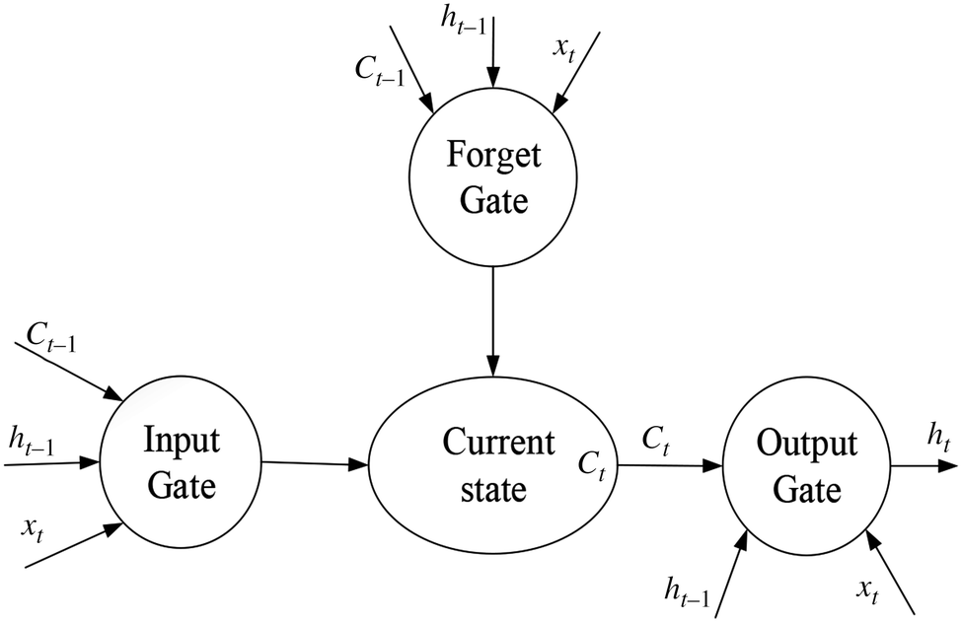

The gate allows information to be passed selectively and Eq. 1 shows the default activation function of the LSTM network, the sigmoid function. The LSTM can add and delete information for neurons through the gating unit. To determine selectively whether information passes or not, it consists of a Sigmoid neural network layer and a pair multiplication operation. Each element output by the Sigmoid layer is a real number between [0, 1], representing the weight through which the corresponding information passes. In the LSTM neural network, there is also a layer containing tanh activation function which shown in Eq. 2. It is used for updating the state of neurons.

Chapter 3
SYSTEM ANALYSIS
3.SYSTEM ANALYSIS
3.1 ANACONDA
Anaconda is a free and open-source distribution of the Python and R programming languages for scientific computing (data science, machine learning applications, large-scale data processing, predictive analytics, etc.), that aims to simplify package management and deployment. Package versions are managed by the package management system conda. The Anaconda distribution is used by over 12 million users and includes more than 1400 popular data-science packages suitable for Windows, Linux, and MacOS.
Anaconda distribution comes with more than 1,400 packages as well as the Conda package and virtual environment manager, called Anaconda Navigator , so it eliminates the need to learn toinstall each library independently.
The open source packages can be individually installed from the Anaconda repository with the conda install command or using the pip install command that is installed with Anaconda. Pip packages provide many of the features of conda packages and in most cases they can work together.
Custom packages can be made using the conda build command, and can be shared with others by uploading them to Anaconda Cloud, PyPI or other repositories.
The default installation of Anaconda2 includes Python 2.7 and Anaconda3 includes Python .However, you can create new environments that include any version of Python packaged with conda .
Anaconda Navigator: Anaconda Navigator is a desktop graphical user interface (GUI) included in Anaconda distribution that allows users to launch applications and manage conda packages, environments and channels without using command-line commands. Navigator can search for packages on Anaconda Cloud or in a local Anaconda Repository, install them in an environment, run the packages and update them. It is available for Windows, macOS and Linux.
The following applications are available by default in Navigator :
• JupyterLab
• Jupyter Notebook
• QtConsole
• Spyder
• Glueviz
• Orange
• Rstudio
• Visual Studio Code
- JupyterLab:This is an extensible working environment for interactive and reproducible computing, based on the JupyterNotebook andArchitecture.
- Qt Console:It is the PyQt GUI that supports inline figures, proper multiline editing with syntax highlighting, graphical calltips andmore.
- Spyder:Spyder is a scientific Python Development Environment. It is a powerful Python IDEwithadvance debiting,interactivetesting,debuggingandintrospectionfeatures.
- VS Code:It is a streamlined code editor with support for development operations like debugging, task running and versioncontrol.
- Glueviz:This is used for multidimensional data visualization across files. It explores relationships within and among relateddatasets.
- Orange 3:It is a component-based data mining framework. This can be used for data visualization and data analysis. The workflows in Orange 3 are very interactive and provide a largetoolbox.
- Rstudio:It is a set of integrated tools designed to help you be more productive with R. It includes R essentials andnotebooks.

Conda
Conda is an open source, cross-platform, language-agnostic package manager and environment management system that installs, runs, and updates packages and their dependencies. It was created for Python programs, but it can package and distribute software for any language (e.g.,R), including multi-language projects. The Conda package and environment manager is included in all versions of Anaconda, Miniconda,and Anaconda Repository.
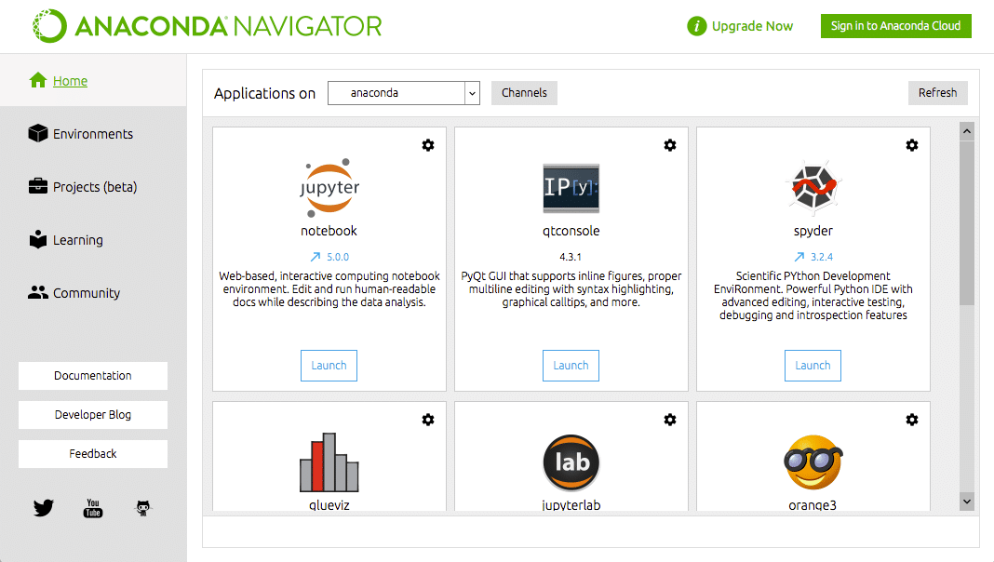
Anaconda Cloud
Anaconda Cloud is a package management service by Anaconda where you can find, access,store and share public and private notebooks, environments, and conda and PyPI packages.
Cloud hosts useful Python packages, notebooks and environments for a wide variety of applications. You do not need to log in or to have a Cloud account, to search for public packages,download and install them.
You can build new packages using the Anaconda Client command line interface (CLI), then manually or automatically upload the packages to Cloud.
Programming language : PYTHON
Features of Anaconda Notebooks
- Cloud-hosted JupyterLab instance
- Ready-to-code Anaconda environment with hundreds of packages
- Native conda package and environment management
- 5GB of fast, backed-up, persistent storage
- Custom extensions
- Access to a library of sample projects and notebooks

About Python
Python is an interpreted, high-level, general-purpose programming language. Created by Guidovan Rossum and first released in 1991, Python has a design philosophy that emphasizes code readability, notably using significant whitespace. It provides constructs that enable clear programming on both small and large scales. Van Rossum led the language community until stepping down as leader in July 2018.Python features a dynamic type system and automatic memory management. It supports multiple programming paradigms, including object-oriented,imperative, functional and procedural, it also has a comprehensive standard library.Python interpreters are available for many operating systems. CPython, the reference implementation of Python, is open source software and has a community-based development model, as do nearly all of Python&#39;s other implementations. Python and CPython are managed by the non-profit Python
Software Foundation.
The Python version release dates are as follows:
Python 1.0 - Jan 1994
Python 1.5 - 31 Dec 1997
Python 1.5.2 - April 1999
Python 1.6 - 05 Sep 2000
Python 2.0 - 16 Oct 2000
Python 2.0.1 - 22 Jun 2001
Python 2.1 - 17 Apr 2001
Python 2.2 - 21 Dec 2001
Python 2.3 - 29 Jul 2003
Python 2.4 - 30 Nov 2004
Python 2.5 - 19 Sep 2006
Python 2.6 - 01 Oct 2008
Python 2.7 - 03 Jul 2010
Python 3.0 - 03 Dec 2008
Python 3.6 - Dec 2016
Python 3.6.5 - March 2018
Python 3.7.0 - Oct 2019
Python 3.8 - Dec 2008
Python 3.9 - Oct 2020

Software requirements:
- Operating System: Windows10
- Coding Language:Python

• IDE: Anaconda, Jupiter notebook
• Libraries:
➢ Matplotlib
➢ Numpy
➢ Pandas
➢ Regex
➢ Requests
➢ Scikit-learn
➢ Scipy
➢ Sklearn.
• Language:Python
4 JupyterNotebook: This is aweb-based,interactivecomputingnotebookenvironment.We can edit and run human-readable docs while describing the dataanalysis.
The Jupyter Notebook is an open-source web application that you can use to create and share documents that contain live code, equations, visualizations, and text. Jupyter Notebook is maintained by the people at ProjectJupyter.
Jupyter Notebooks are a spin-off project from the IPython project, which used to have an IPython Notebook project itself. The name, Jupyter, comes from the core supported programming languages that it supports: Julia, Python, and R. Jupyter ships with the IPython kernel, which allows you to write your programs in Python, but there are currently over 100 other kernels that you can alsouse.
The Jupyter Notebook is not included with Python, so if you want to try it out, you will need to install Jupyter.
There are many distributions of the Python language. This article will focus on just two of them for the purposes of installing Jupyter Notebook. The most popular is CPython, which is the reference version of Python that you can get from their website. It is also assumed that you are usingPython.

HOW TO INSTALL PYTHON (ENVIRONMENT SET UP ):
Installation on Windows
Visit the link https://www.python.org/downloads/to download the latest release of Python. In this process, we will install Python 3.6.7 on our Windows operatingsystem.

Double-click the executable file which is downloaded; the following window will open. Select Customize installation and proceed
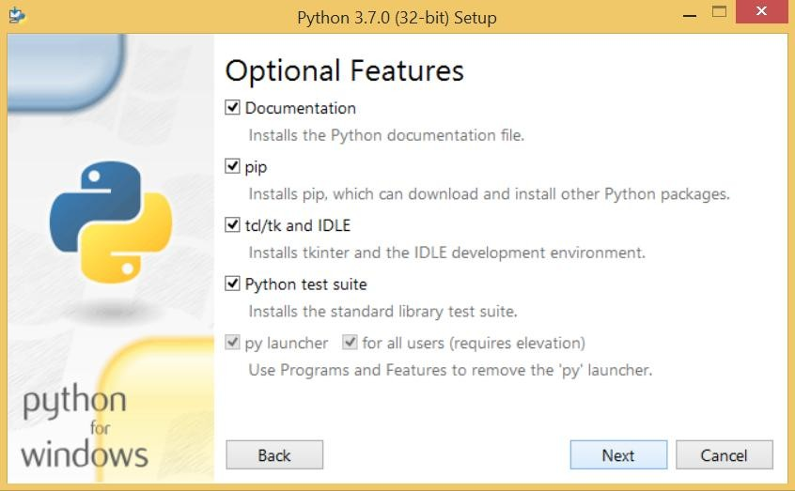
Fig: 3.6 Python Installation
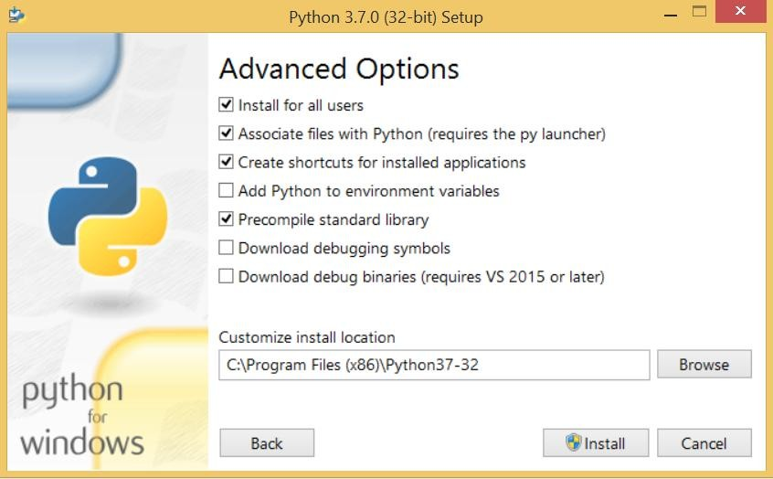

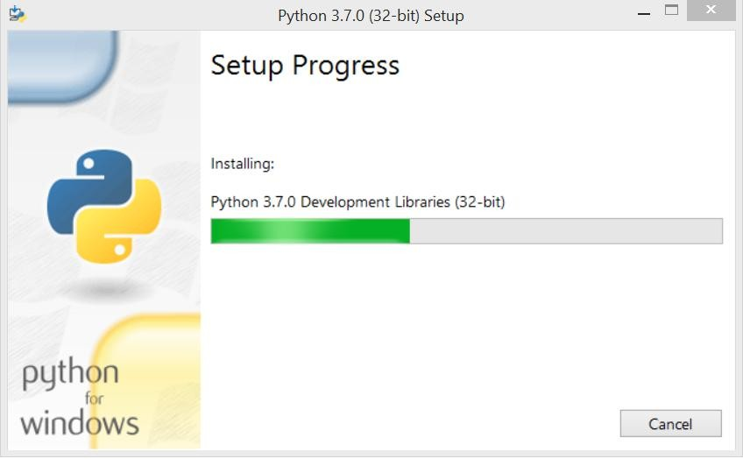

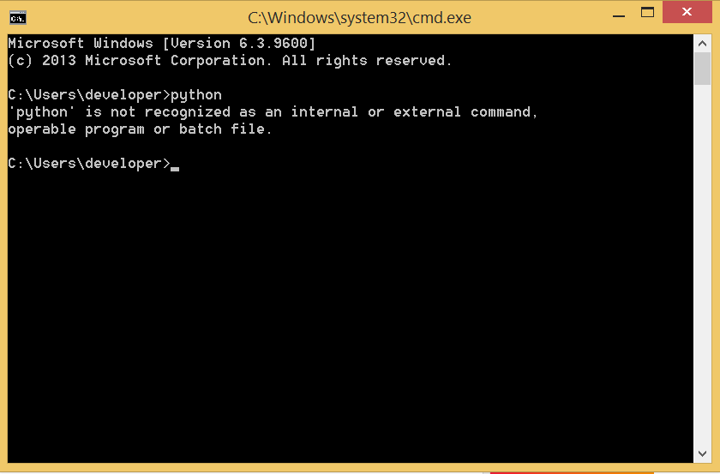

To set the path of python, we need to the right click on "my computer" and go to Properties
→ Advanced → Environment Variables
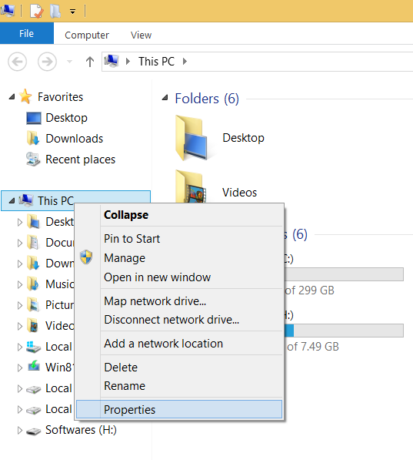

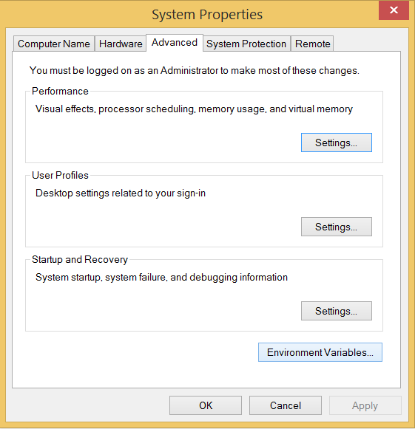

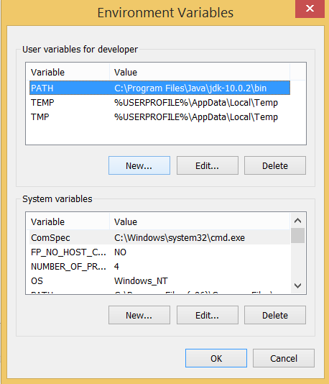

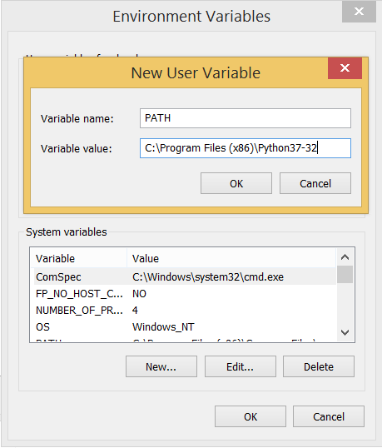

Now, the path is set, we are ready to run python on our local system. Restart CMD, and type python again. It will open the python interpreter shell where we can execute the python statements.

3.2HARDWARE REQUIREMENTS
For developing the application the following are the Hardware Requirements:
      - Processor:I5
      - RAM: 8 GB
      - Space on Hard Disk:1TB
      - Graphics card:512GB

Hardware requirements
• Processor: i3
• RAM: 8GB
• Hard Disk: 1TB

3FUNCTIONALREQUIREMENTS
In software engineering, a functional requirement defines a function of a software system or its component. A function is described as a set of inputs, the behavior, and outputs (see also software). Functional requirements may be calculations, technical details, data manipulation and processing and other specific functionality that define what a system is supposed to accomplish. Behavioral requirements describing all the cases where the system uses the functional requirements are captured in use cases. Generally, functional requirements
are expressed in the form system shall do <requirement>. The plan for implementing functional requirements is detailed in the system design. In requirements engineering, functional requirements specify particular results of a system. Functional requirements drive the application architecture of a system. A requirements analyst generates use cases after gathering and validating a set of functional requirements. The hierarchy of functional requirements is: user/stakeholder request -> feature -> use case -> business rule.
Functional requirements drive the application architecture of a system. A requirements analyst generates use cases after gathering and validating a set of functional requirements. Functional requirements may be technical details, data manipulation and other specific functionality of the project is to provide the information to theuser.

NON FUNCTIONALREQUIREMENTS
In systems engineering and requirements engineering, a non-functional requirement is a requirement that specifies criteria that can be used to judge the operation of a system, rather than specific behaviors
The project non-functional requirements include the following.
    - Updating Workstatus.
    - Problemresolution.
    - Error occurrence in thesystem.
    - Customerrequests.
Availability:A system’s “availability” or “uptime” is the amount of time that is operational and available for use. It’s related to is the server providing the service to the

users in displaying images. As our system will be used by thousands of users at any time our system must be available always. If there are any cases of updations they must be performed in a short interval of time without interrupting the normal services made available to the users.
Efficiency: Specifies how well the software utilizes scarce resources: CPU cycles, disk space, memory, bandwidth etc. All of the above mentioned resources can be effectively used by performing most of the validations at client side and reducing the workload on server by using JSP instead of CGI which is being implementednow.
Flexibility: If the organization intends to increase or extend the functionality of the software after it is deployed, that should be planned from the beginning; it influences choices madeduring the design, development, testing and deployment of the system. New modules can be easily integrated to our system without disturbing the existing modules or modifying the logical database schema of the existingapplications.

Portability: Portability specifies the ease with which the software can be installed on all necessary platforms, and the platforms on which it is expected to run. By using appropriate server versions released for different platforms our project can be easily operated on any operating system, hence can be said highlyportable.

Scalability: Software that is scalable has the ability to handle a wide variety of system configuration sizes. The nonfunctional requirements should specify the ways in which the system may be expected to scale up (by increasing hardware capacity, adding machines etc.). Our system can be easily expandable. Any additional requirements such as hardware or software which increase the performance of the system can be easily added. An additional server would be useful to speed up the application.
Integrity: Integrity requirements define the security attributes of the system, restricting access to features or data to certain users and protecting the privacy of data entered into the software. Certain features access must be disabled to normal users such as adding the details of files, searching etc which is the sole responsibility of the server. Access can be disabled by providing appropriate logins to the users for onlyaccess.
Usability: Ease-of-use requirements address the factors that constitute the capacity of the software to be understood, learned, and used by its intended users. Hyperlinks will be provided for each and every service the system provides through which navigation will be easier. A system that has high usability coefficient makes the work of the user easier.
Performance: The performance constraints specify the timing characteristics of thesoftware.

Chapter 4
SYSTEM DESIGN
4.SYSTEM DESIGN
Block Diagram
There are three key contributions of the work (1) a new dataset extracted and cleaned (2) a model selection and (3) a evolution algorithm model.

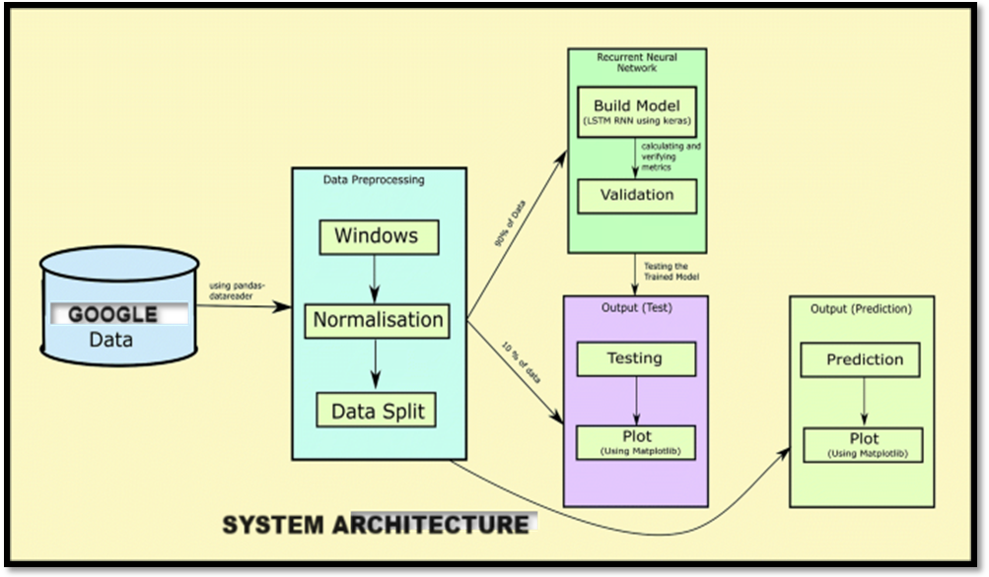
Fig4.1: Google Stock Prediction System Architecture

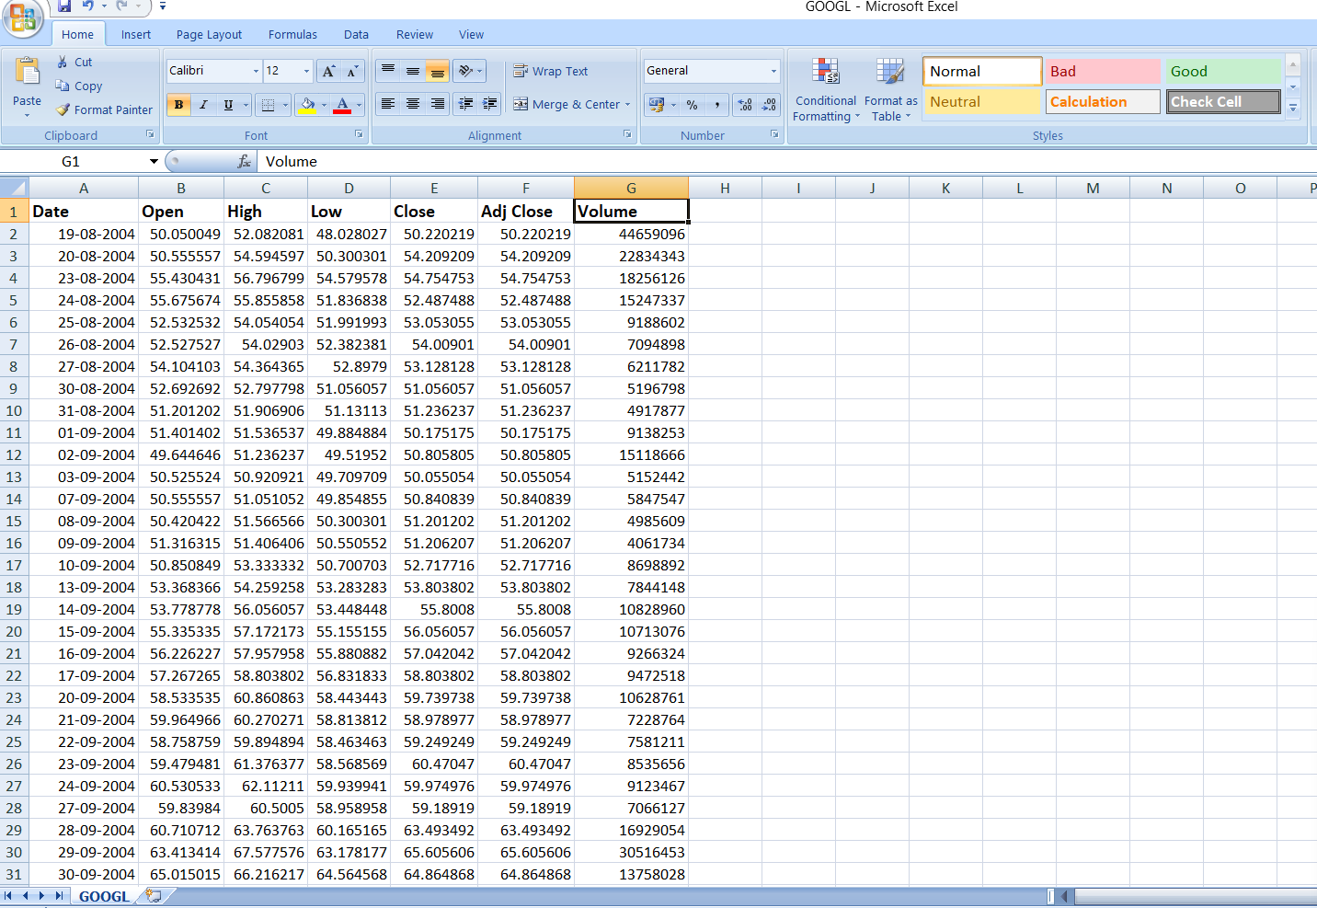
Fig4.2: Dataset
UML DIAGRAMS:

4.1 Usecase diagram

The purpose of use case diagram is to capture the dynamic aspect of a system. However, this definition is too generic to describe the purpose, as other four diagrams (activity, sequence, collaboration, and Statechart) also have the same purpose. We will look into some specific purpose, which will distinguish it from other four diagrams.

Use case diagrams are used to gather the requirements of a system including internal and external influences. These requirements are mostly design requirements. Hence, when a system is analyzed to gather its functionalities, use cases are prepared and actors are identified.
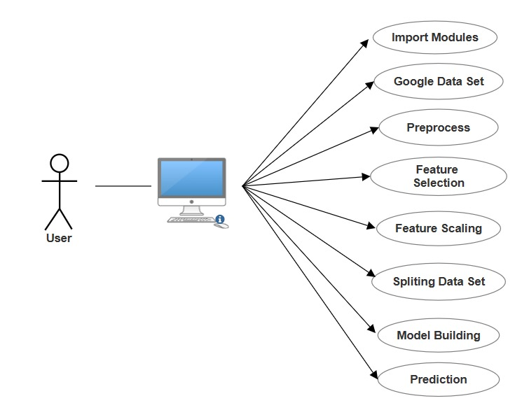

5.2 class diagram

Class diagram is a static diagram. It represents the static view of an application. Class diagram is not only used for visualizing, describing, and documenting different aspects of a system but also for constructing executable code of the software application.

Class diagram describes the attributes and operations of a class and also the constraints imposed on the system. The class diagrams are widely used in the modeling of object oriented systems because they are the only UML diagrams, which can be mapped directly with object-oriented languages.

Class diagram shows a collection of classes, interfaces, associations, collaborations, and constraints. It is also known as a structural diagram.
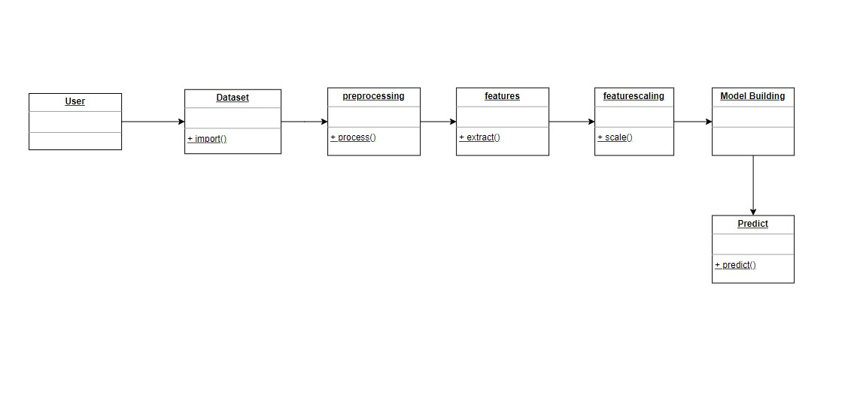

4.3 Sequence diagram

The sequence diagram represents the flow of messages in the system and is also termed as an event diagram. It helps in envisioning several dynamic scenarios. It portrays the communication between any two lifelines as a time-ordered sequence of events, such that these lifelines took part at the run time. In UML, the lifeline is represented by a vertical bar, whereas the message flow is represented by a vertical dotted line that extends across the bottom of the page. It incorporates the iterations as well as branching.

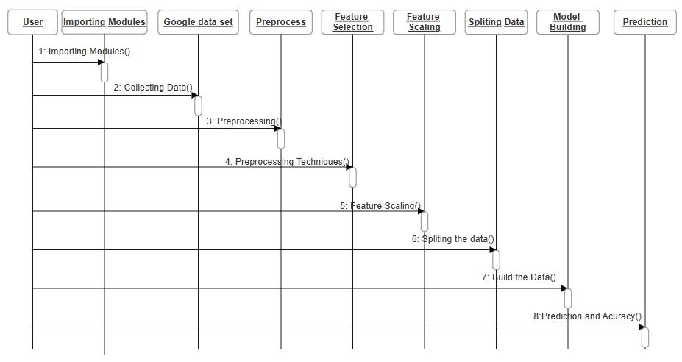

4.4 Collaboration diagram
A collaboration diagram, also known as a communication diagram, is an illustration of the relationships and interactions among software objects in the Unified Modelling Language (UML). Developers can use these diagrams to portray the dynamic behaviour of a particular use case and define the role of each object. To create a collaboration diagram, first identify the structural elements required to carry out the functionality of an interaction. Then build a model using the relationships between those elements. Several vendors offer software for creating and editing collaboration diagrams.
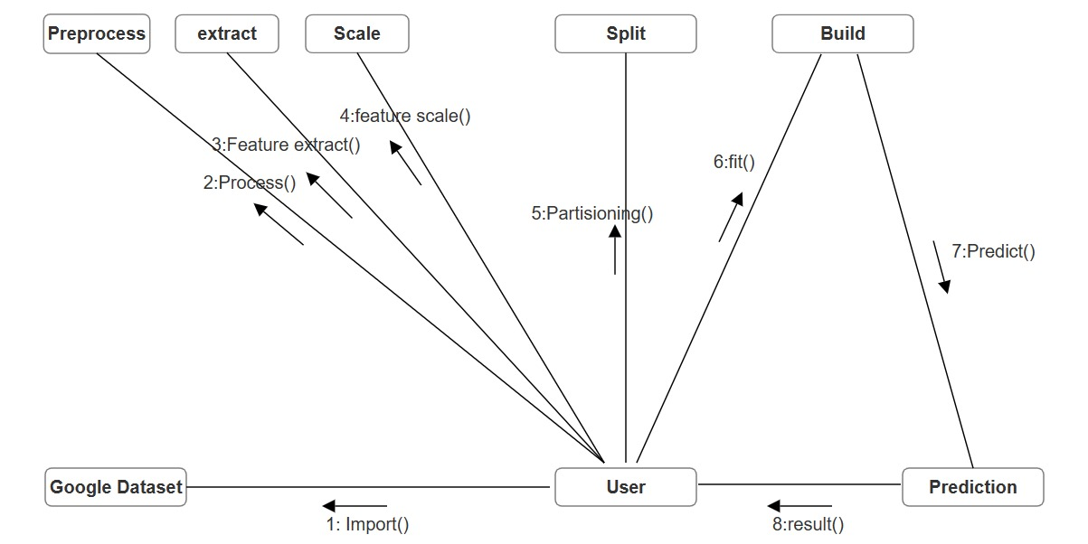

4.5 Component diagram

A component diagram breaks down the actual system under development into various high levels of functionality. Each component is responsible for one clear aim within the entire system and only interacts with other essential elements on a need-to-know basis.

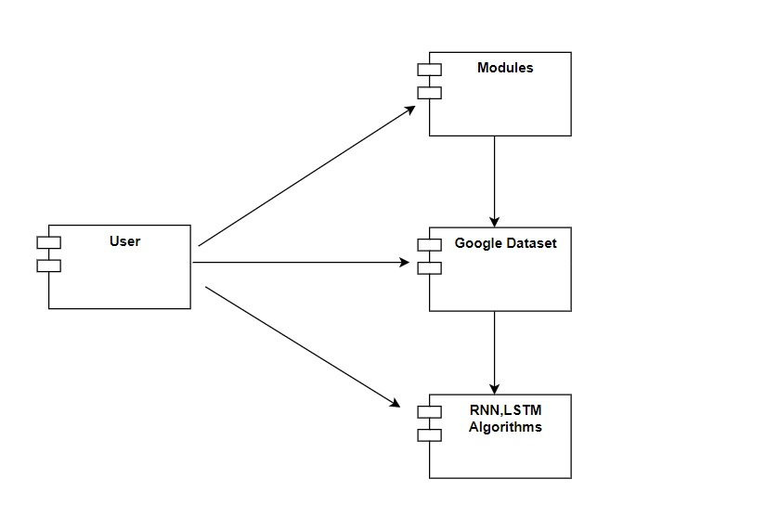

4.6 Activity diagram

Activity Diagrams are used to illustrate the flow of control in a system and refer to the steps involved in the execution of a use case. It is a type of behavioral diagram and we can depict both sequential processing and concurrent processing of activities using an activity diagram ie an activity diagram focuses on the condition of flow and the sequence in which it happens.
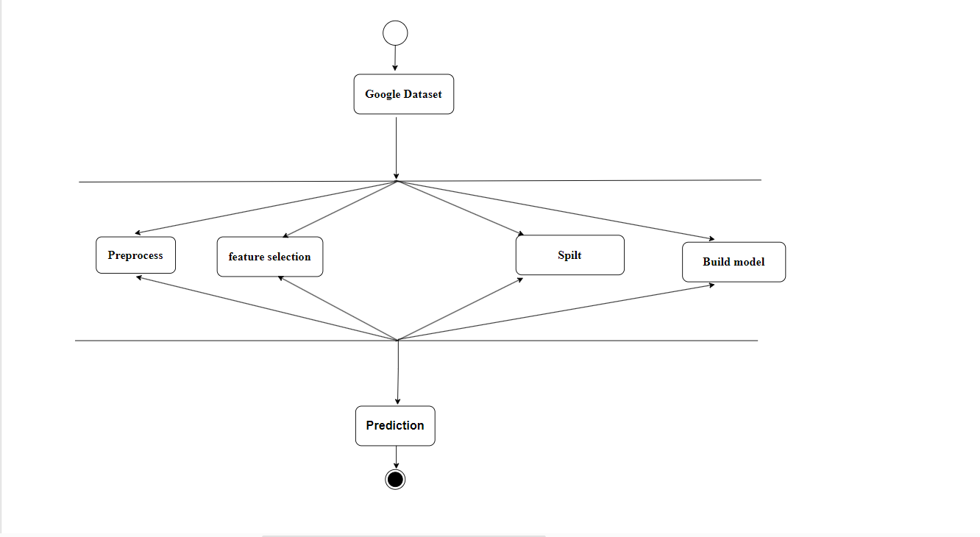

Chapter 5
CODING AND IMPLEMENTATION

5. IMPLEMENTATION&CODING
MODULES OF PROJECT

DATA COLLECTION (REVIEWS AND DATA SETS )

DATA PRE PROCESSING

BULID THE MODEL AFTER TRAINING

PREDECTION OF RATING

DATA COLLECTION:
The sample data has been collected from Google stock.
Data pre- processing:
Data preprocessing is a technique that is used to convert raw data into a clean dataset. The data is gathered from different sources is in raw format which is not feasible for the analysis. Pre-processing for this approach takes 4 simple yet effective steps.
- Attribute selection: Some of the attributes in the initial dataset that was not pertinent (relevant) to the experiment goal were ignored.
- Cleaning missing values:In some cases, the dataset contain missing values. We need to be equipped to handle the problem when we come across them. Obviously, you could remove the entire line of data but what if you're inadvertently removing crucial informationafter all we might not need to try to do that. One in every of the foremost common plan to handle the matter is to require a mean of all the values of the same column and have it to replace the missing data. The library used for the task is called SCIKIT Learn preprocessing. It contains a class called Imputer which will help us take care of the missing data.
Training and Test data: Splitting the Dataset into Training set and Test Set Now the next step is to split our dataset into two. Training set and a Test set. We will train our machine learning models on our training set, i.e., our machine learning models will try to understand any correlations in our training set and then we will test the models on our test set to examine how accurately it will predict. A general rule of the thumb is to assign 70% of the dataset to training set and therefore the remaining 30% to test set.

- Algorithms and Techniques

Long short-term memory is an artificial recurrent neural network (RNN) architecture used in deep learning. Unlike standard feedforward neural networks, Long short-term Memory has feedback connections. It can process single data points (e.g., images) and entire data sequences (such as speech or video inputs).
LSTM models can store information over some time. They have a memory capacity.
This characteristic is beneficial when we deal with Time-Series or Sequential Data. When using an LSTM model, we can decide what information will be stored and discarded. We do that using the "gates."
LSTM has three gates:
- The input gate: This gate adds information to the cell state,
- The forget gate: It removes the knowledge that the model no longer requires,
- The output gate: This gate at LSTM selects the information shown as output.
However, some variants of the LSTM model, such as Gated Recurrent Units (GRUs), don't have an output gate. Long short-term memory networks are popularly used on time-series data for classification and making predictions. Its popularity in time-series applications is that there can be several lags of unknown duration between important events in a time series.

To implement Long Short-Term Memory (LSTM) in analyzing Google stock, one typically utilizes historical stock price data as input to the LSTM model. This data can include various features such as opening price, closing price, highest and lowest prices of the day, trading volume, and any relevant external factors affecting the stock market. LSTM networks are a type of recurrent neural network (RNN) architecture specifically designed to capture long-term dependencies in sequential data, making them suitable for time-series analysis like stock price prediction.
The first step in implementing LSTM for Google stock analysis involves data preprocessing, where the historical stock price data is cleaned, normalized, and partitioned into training, validation, and test sets. The LSTM model architecture is then defined, typically comprising multiple LSTM layers followed by one or more fully connected layers for regression or classification tasks. During training, the model learns to predict future stock prices based on historical patterns in the input data.
Once the LSTM model is trained, it can be used for various tasks such as short-term and long-term stock price prediction, anomaly detection, and identifying potential trading opportunities. However, it's essential to note that while LSTM networks can capture complex patterns in the data, stock market prediction remains inherently uncertain due to its dynamic and volatile nature. Therefore, implementing LSTM for Google stock analysis requires careful consideration of various factors and constant monitoring to adapt to changing market conditions.
Deep recurrent neural network is composed of LSTM, so its operation mechanism is same as LSTM. During the process of constructing the task model, the dropout method was used. Dropout refers to the temporary discarding of the neural network unit from the network according to a certain probability during the training of the deep learning network, which is a means to prevent over-fitting. The principle of dropout operation is that the neurons in each layer are randomly deleted with probability P in a training iteration, and the data in this iteration are trained with the network composed of the remaining (1 − p)*N neurons, thus alleviating the over-fitting problem.
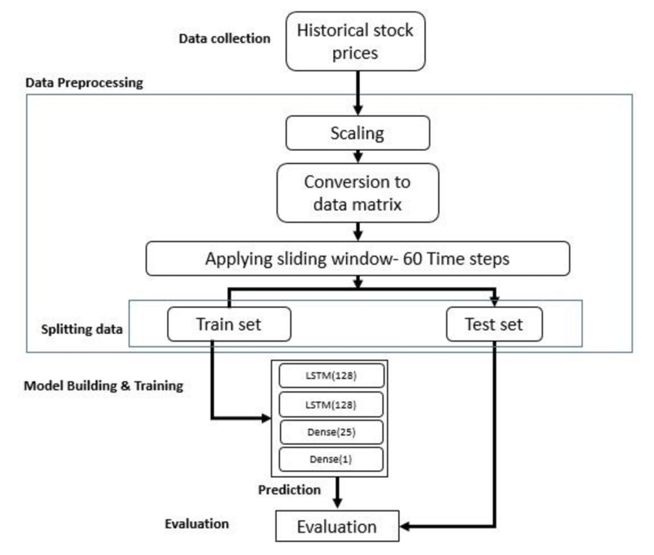
In this implementation:
- We load the dataset containing historical Google stock prices.
- The data is normalized using Min-Max scaling to a range between 0 and 1.
- We prepare the data for the LSTM model by creating sequences of data points with a specified number of time steps.
- The LSTM model architecture is defined, comprising two LSTM layers followed by a dense layer.
- The model is compiled with the Adam optimizer and mean squared error loss function.
- We train the model using the training data.
- Finally, we make predictions on the test data, inverse-transform the predictions to their original scale, and visualize both the actual and predicted stock prices.
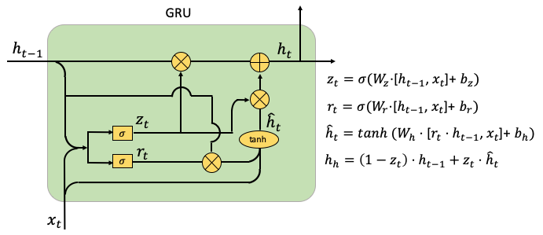

The LSTM-based deep recurrent neural network model with dropout layer was used as the contrast model to verify the feasibility and applicability of the proposed associated neural network model. The structure of LSTM-based deep recurrent neural network is shown
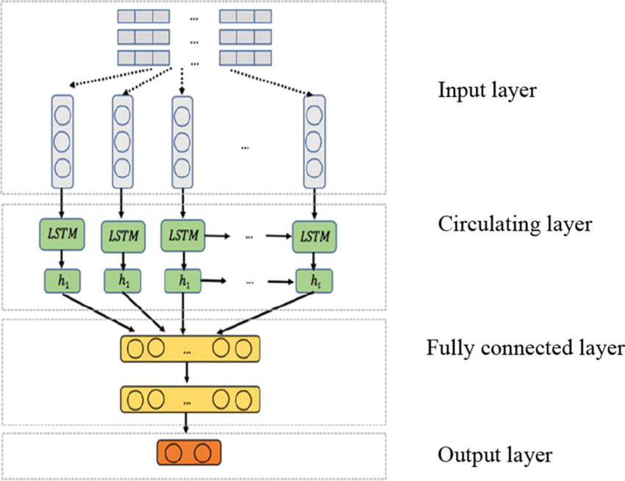

Source Code:

# # Stock Price Prediction
#!/usr/bin/env python
# coding: utf-8
# In[1]:
#Importing & Preprocessing Data:
import numpy as np
import pandas as pd
import matplotlib.pyplot as plt
import seaborn as sns
# In[2]:
data = pd.read_csv(r"/content/drive/MyDrive/GOOGL.csv", date_parser=True)
data.head()
# In[3]:
# Divide Data into Training and Test set
# Training Data
data_training = data[data['Date']<'2020-05-01'].copy()
data_training
# In[4]:
# Divide Data into Training and Test set
# Test Data
data_test = data[data['Date']>='2020-05-01'].copy()
data_test
# In[5]:
training_data = data_training.drop(['Date','Adj Close'],axis=1)
training_data.head()
# In[6]:
# Here we have to predict the Open i.e opening price of that particular stock.
# Data Preprocessing
from sklearn.preprocessing import MinMaxScaler
scaler = MinMaxScaler()
training_data = scaler.fit_transform(training_data)
training_data
# In[7]:

X_train = []
y_train = []
for i in range(30, training_data.shape[0]):
X_train.append(training_data[i-30:i])
y_train.append(training_data[i,0])
X_train, y_train = np.array(X_train), np.array(y_train)
X_train.shape
# In[ ]:

#Build The RNN Model:
# In[8]:

# Building LSTM
from tensorflow.keras import Sequential
from tensorflow.keras.layers import Dense, LSTM, Dropout
regression = Sequential()
regression.add(LSTM(units=50, activation="relu", return_sequences=True, input_shape=(X_train.shape[1], 5)))
regression.add(Dropout(0.2))
regression.add(LSTM(units=50, activation="relu", return_sequences=True, input_shape=(X_train.shape[1], 5)))
regression.add(Dropout(0.3))
regression.add(LSTM(units=50, activation="relu", return_sequences=True, input_shape=(X_train.shape[1], 5)))
regression.add(Dropout(0.4))
regression.add(LSTM(units=50, activation="relu"))
regression.add(Dropout(0.5))
regression.add(Dense(units=1))
regression.summary()
# In[11]:
# Compile and Fit the model
regression.compile(optimizer='adam', loss="mean_squared_error")
regression.fit(X_train,y_train,epochs=20,batch_size=32)
# In[12]:
loss=0.0030
accuracy=(1-loss)*100
accuracy
# In[13]:
#Predict Values:
# Prepare test data
data_test.head()
# In[14]:
past_30_days = data_training.tail(30)
df = past_30_days.append(data_test, ignore_index=True)
df = df.drop(['Date', 'Adj Close'],axis=1)
df.head()
# In[15]:
inputs = scaler.transform(df)
inputs
# In[16]:
X_test = []
y_test = []
for i in range(30, inputs.shape[0]):
X_test.append(inputs[i-30:i])
y_test.append(inputs[i,0])

X_test, y_test = np.array(X_test),np.array(y_test)
X_test.shape, y_test.shape
# In[17]:
y_pred = regression.predict(X_test)
y_pred
# In[18]:

scaler.scale_
# In[19]:

scale = 1/2.13419869e-03
scale

# In[20]:
y_pred = y_pred * scale
y_test = y_test * scale

# In[21]:
# Visualize The Data and Check Accuracy:

# In[22]:

# Visualize the data
plt.figure(figsize=(14,5))
plt.plot(y_test, color="red", label="Real Google Stock Price")
plt.plot(y_pred, color="blue", label="Predict Google Stock Price")
plt.title("Google Stock Price Prediction")
plt.xlabel('Time')
plt.ylabel('Google Stock Price')
plt.legend()
plt.show()

Chapter 6
SYSTEM TESTING
6.SYSTEM TESTING
6.1 LEVELS OF TESTING

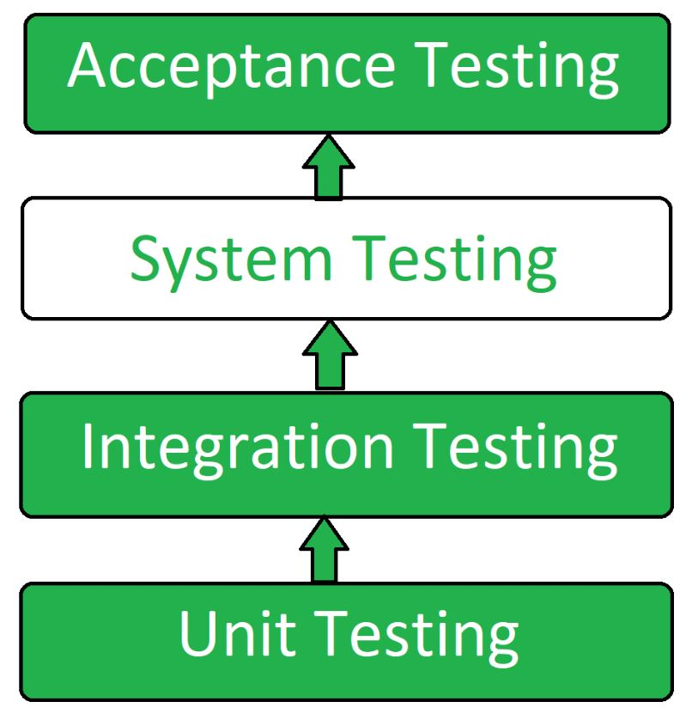
System Testing Process:
System Testing is performed in the following steps:
- Test Environment Setup:
Create testing environment for the better quality testing.
- Create Test Case:
Generate test case for the testing process.
- Create Test Data:
Generate the data that is to be tested.
- Execute Test Case:
After the generation of the test case and the test data, test cases are executed
- Defect Reporting:
Defects in the system are detected.
- Regression Testing:
It is carried out to test the side effects of the testing process.
- Log Defects:
Defects are fixed in this step.
- Retest:
If the test is not successful then again test is performed.
Unit Testing
Unit Testing is a level of software testing where individual units/ components of a software are tested. The purpose is to validate that each unit of the software performs as designed. A unit is the smallest testable part of any software. It usually has one or a few inputs and usually a single output. In procedural programming, a unit may be an individual program, function, procedure, etc. In object-oriented programming, the smallest unit is a method, which may belong to a base/ super class, abstract class or derived/ child class. (Some treat a module of an application as a unit. This is to be discouraged as there will probably be many individual units within that module.) Unit testing frameworks, drivers, stubs, and mock/ fake objects are used to assist in unit testing.
Integration Testing
Integration Testing is a level of software testing where individual units are combined and tested as a group. The purpose of this level of testing is to expose faults in the interaction between integrated units. Test drivers and test stubs are used to assist in Integration Testing.Some different types of integration testing are big-bang, mixed (sandwich), risky-hardest, top-down, and bottom-up. Other Integration Patterns are: collaboration integration, backbone integration, layer integration, client-server integration, distributed services integration and high-frequency integration. In the big-bang approach, most of the developed modules are coupled together to form a complete software system or major part of the system and then used for integration testing. This method is very effective for saving time in the integration testing process. However, if the test cases and their results are not recorded properly, the entire integration process will be more complicated and may prevent the testing team from achieving the goal of integration testing.
Bottom-up testing is an approach to integrated testing where the lowest level components are tested first, then used to facilitate the testing of higher level components. The process is repeated until the component at the top of the hierarchy is tested. All the bottom or low-level modules, procedures or functions are integrated and then tested. After the integration testing of lower level integrated modules, the next level of modules will be formed and can be used for integration testing. This approach is helpful only when all or most of the modules of the same development level are ready.
This method also helps to determine the levels of software developed and makes it easier to report testing progress in the form of a percentage. Top-down testing is an approach to integrated testing where the top integrated modules are tested and the branch of the module is tested step by step until the end of the related module.

System Testing
System testing of software or hardware is testing conducted on a complete, integrated system to evaluate the system's compliance with its specified requirements. System testing falls within the scope of black-box testing, and as such, should require no knowledge of the inner design of the code or logic. As a rule, system testing takes, as its input, all of the "integrated" software components that have passed integration testing and also the software system itself integrated with any applicable hardware system(s).
The purpose of integration testing is to detect any inconsistencies between the software units that are integrated together (called assemblages) or between any of the assemblages and the hardware. System testing is a more limited type of testing; it seeks to detect defects both within the "inter-assemblages" and also within the system as a whole. System Testing (ST) is a black box testing technique performed to evaluate thecomplete system the system's compliance against specified requirements. In System testing, the functionalities of the system are tested from an end-to-end perspective.
System Testing is usually carried out by a team that is independent of the development team in order to measure the quality of the system unbiased. It includes both functional and Non-Functional testing.

Black Box Testing
Black-box testing is a method of software testing that examines the functionality of an application without peering into its internal structures or workings. This method of test
can be applied virtually to every level of software testing: unit, integration, system and acceptance. It is sometimes referred to as specification-based testing. Specific knowledge of the application's code/internal structure and programming knowledge in general is not required. The tester is aware of what the software is supposed to do but is not aware of how it does it. For instance, the tester is aware that a particular input returns a certain, invariable output but is not aware of how the software produces the output in the first place.

White Box Testing
White-box testing (also known as clear box testing, glass box testing, transparent box testing, and structural testing) is a method of testing software that tests internal structures or workings of an application, as opposed to its functionality (i.e. black-box testing). In white-box

testing an internal perspective of the system, as well as programming skills,The tester chooses inputs to exercise paths through the code and determine the expected outputs. This is analogous to testing nodes in a circuit, e.g. in-circuit testing (ICT). White-box testing can be applied at the unit, integration and system levels of the software testing process. Although traditional testers tended to think of white-box testing as being done at the unit level, it is used for integration and system testing more frequently today. It can test paths within a unit, paths between units during integration, and between subsystems during a system–level test. Though this method oftest design can uncover many errors or problems, it has the potential to miss unimplemented parts of the specification or missing requirements.

Chapter 7
SCREENSHOTS

7. SCREENSHOTS
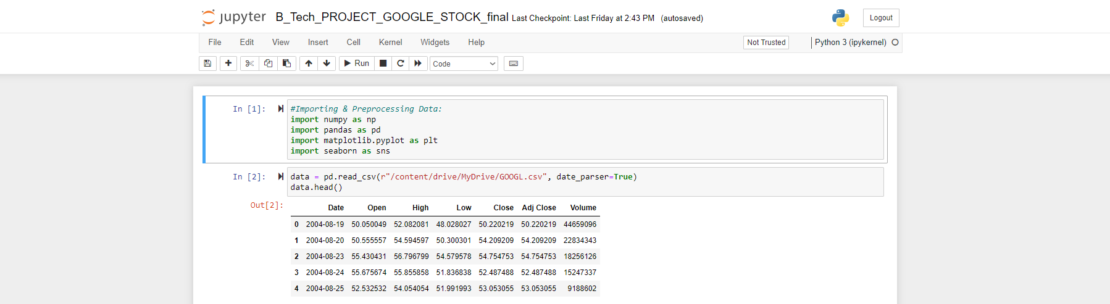
Figure 7.1

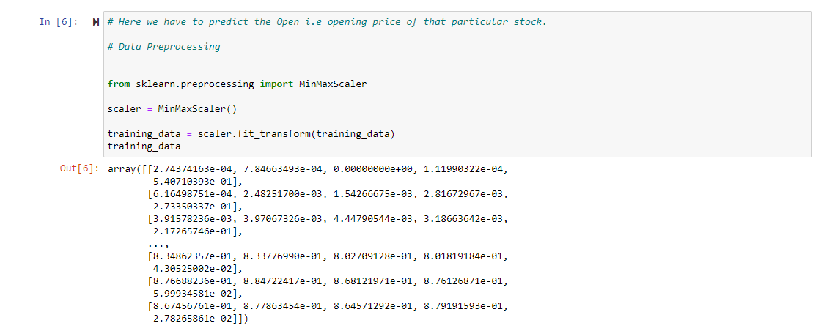
Figure:7.2
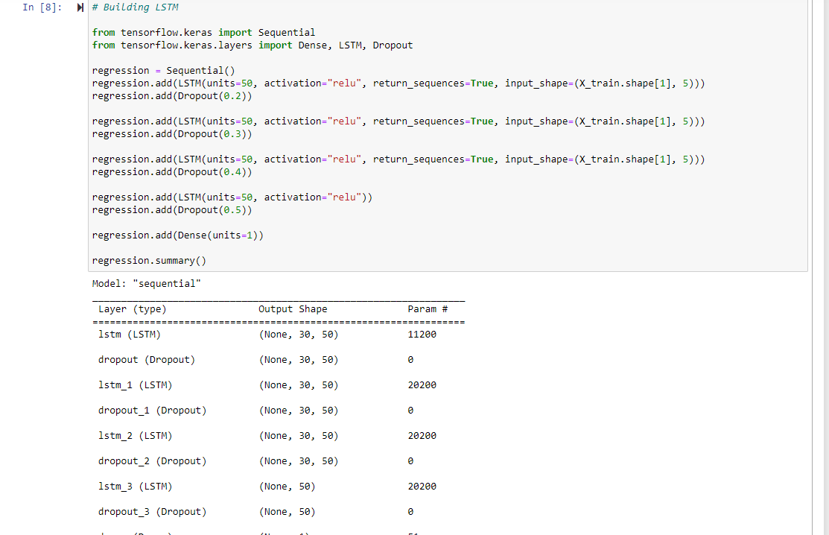
Figure 7.3
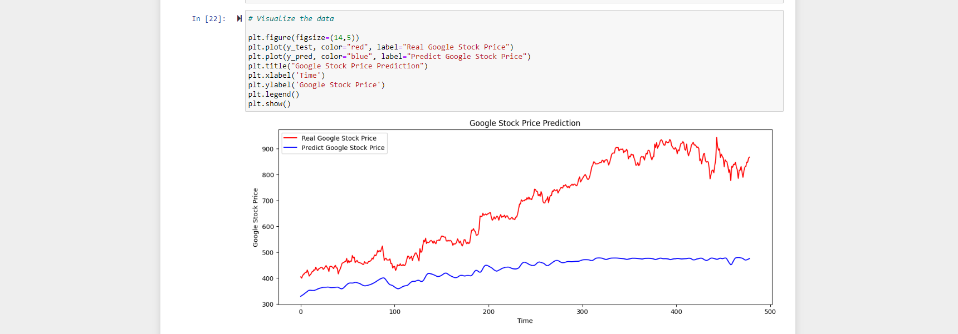

Figure 7.4

Chapter 8
CONCLUSION

8. CONCLUSION
In this project, we used the LSTM recurrent neural networks to extract feature value and analyze the stock data. The LSTM deep learning model we used this time, which combines the attention mechanism with depth and uses the gradient descent method to achieve a faster speed approximation, had better performance than the previous ARIMA, ANN and SVM models, and based on the algorithm, it solved the problems of easily falling into local extreme values and slow convergence speed. In general, the overall trend of image prediction is basically consistent with the actual trend, and it is also suitable for predicting long-term trends. While the accuracy rate was not very satisfactory, we found that it can still be improved, especially if the correct threshold was set to effectively exclude very low or very high yield sequences. This is useful when selecting stocks for analysis.
Finally, based on our comparison of different neural networks and optimization algorithms, better models should be designed to improve prediction accuracy in the future.

Chapter 8
REFERENCES
8.REFERENCES

REFERENCES

[1] Martin Abadi, Ashish Agarwal, Paul Barham, Eugene Brevdo, Zhifeng Chen, Craig Citro,
Greg S. Corrado, Andy Davis, Jeffrey Dean, Matthieu Devin, Sanjay Ghemawat, Ian
Goodfellow, Andrew Harp, Geoffrey Irving, Michael Isard, Yangqing Jia, RafalJozefowicz,
Lukasz Kaiser, Manjunath Kudlur, Josh Levenberg, Dandelion Mane, Rajat Monga, Sherry
Moore, Derek Murray, Chris Olah, Mike Schuster 2015 https://www.tensorflow.org/
Software available from tensorflow.org.

[2] Nick Brooks. 2018. Guided Numeric and Text Exploration E-Commerce. (2018).
https://www.kaggle.com/nicapotato/ guided-numeric-and-text-exploration-e-commerce.

[3] Nick Brooks. 2018. Women’s E-Commerce Clothing Reviews. (2018). https:
//www.kaggle.com/nicapotato/womens-ecommerce-clothing-reviews

[4] François Chollet et al. 2015. Keras. https://github.com/keras-team/keras. (2015).

[5] Ian Goodfellow, YoshuaBengio, and Aaron Courville. 2016. Deep Learning. MIT Press.
http://www.deeplearningbook.org.

[6] Sepp Hochreiter and Jürgen Schmidhuber. 1997. Long short-term memory. Neural
computation 9, 8 (1997), 1735–1780.

[7] J. D. Hunter. 2007. Matplotlib: A 2D graphics environment. Computing In Science &
Engineering 9, 3 (2007), 90–95. https://doi.org/10.1109/MCSE.2007.55

[8] Edward Loper and Steven Bird. 2002. NLTK: The Natural Language Toolkit. In
Proceedings of the ACL Workshop on Effective Tools and Methodologies for Teaching
Natural Language Processing and Computational Linguistics. Philadelphia: Association
for Computational Linguistics.

[9] Wes McKinney. 2010. Data Structures for Statistical Computing in Python. In
proceedings of the 9th Python in Science Conference, Stefan vender Walt and Jarrod
Millman (Eds.). 51 – 56.

[10] Christopher Olah.2015. Neural Networks, Types, and Functional Programming. (2015).
http://colah.github.io/posts/2015-09-NN-Types-FP/

[11] Jeffrey Pennington, Richard Socher, and Christopher D. Manning. 2014. GloVe: Global
Vectors for Word Representation. In Empirical Methods in Natural Language Processing
(EMNLP). 1532–1543. http://www.aclweb.org/anthology/ D14-1162

Chapter 9
APPENDIX

9. APPENDEX
Execution steps
- Open Anaconda Navigator.
- Launch Juypter Note book.
- Open python3 environment.
- Install packages
- Pip install package name
- Conda install –c conda_forge package name
- Packages are:
- Sklearn
- Matplotlib
- Tflearn
- Numpy
- NLTK
5.Run command shift+enter

